**Project Design Phase-1 Solution Architecture**

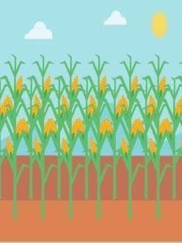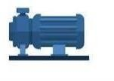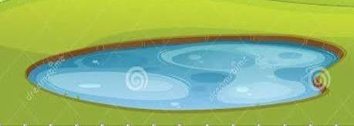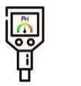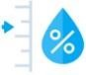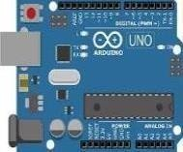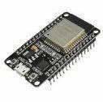

# **Date:** 17 October 2022

**Team ID:** PNT2022TMID37769

# **Project Name:** IOT BASED CROP PROTECTION SYSTEM FOR AGRICULTURE

Camera module

Temperature sensor

Flame sensor

Arduino Micro Gate way

PH level sensor controller module

Cellular tower

Internet Cloud

Router

Water and Now I can monitor my

moisture level farm from anywhere at

sensor anytime

Motor Pump